TAPAN’s Mission
The Texas Association of PeriAnesthesia Nurses, as a component of the American Society of PeriAnesthesia Nurses advances nursing practice through education, research, and standards.

2017 State Conference Committee
Chair:
Sarah Hessling BSN, RN, CPAN
Members:
Lori Rabago BSN, RN
Betty Brookins BSN, RN, CPAN
Gabe Romero BSN, RN, CPAN

TEXAS ASSOCIATION of PERIANESTHESIA NURSES
41st Annual State Conference

Capture the Beauty of San Antonio:
Enlightening PeriAnesthesia Nursing

OCTOBER 13-15, 2017
Drury Plaza Hotel
San Antonio North Stone Oak
823 N. Loop 1604 East
San Antonio, TX 78232
Register online: www.TAPAN.org
OR
Mail completed registration form to:
Texas Association of PeriAnesthesia Nurses
c/o Mollie Smith
(TAPAN Treasurer)
219 Ridgeline Drive
Montgomery, TX 77316

41st TAPAN State Conference

Outcome:
To enlighten perianesthesia practice in order to provide quality patient care

Target Audience:
All perianesthesia nurses and nursing students

Overall Program Objective:
Discuss current clinical topics that relate to perianesthesia practice

Accreditation:
This activity has been submitted to Methodist Healthcare System for approval to award contact hours. Methodist Healthcare System is an approved provider of Continuing Education by the California Board of Registered Nursing.

Disclosure Statement:
All planners and presenters at nursing continuing education activities are required to disclose to the audience any significant financial relationships with manufacturer(s) of any commercial products, goods or services. Such disclosures will be made in writing in the course presentation material.
All registered attendees grant to TAPAN the right to take photographs of attendees and their property in connection with the state conference. Attendees authorize TAPAN to copyright, use and publish the same in print and/or electronically. By registering, attendees agree that TAPAN may use such photographs of attendees with or without names and for any lawful purpose, including for example such purposes as publicity, illustration, advertising, and Web content.
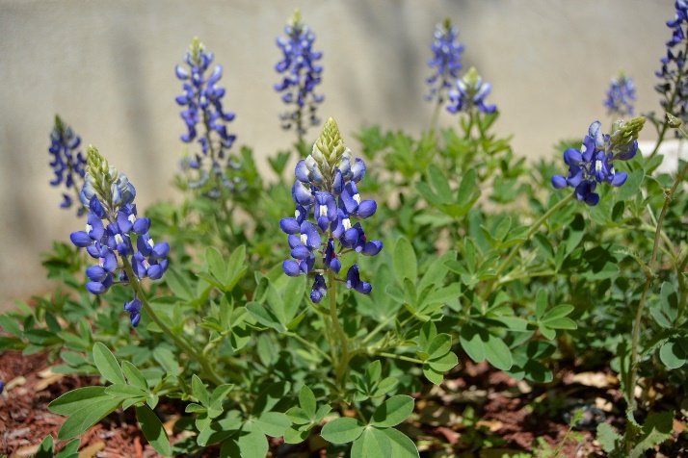
We appreciate you for supporting TAPAN to improve our
perianesthesia practice!!!

Conference Faculty
Brittany Barnhill BS, CCLS
Brett Blakeway MD
Bring canned foods on Friday and Saturday for the San Antonio Food Bank
For every 3 items,
Receive an extra raffle ticket for giveaways
Thomas Brown MD
Ronald Gotanco BA, MD
Gerald Greenfield MD
Bring your past conference bags!
1st time attendees will receive new conference bags.

Elizabeth Higginbotham RN, JD
Debbie James MSN, RN, CCRN-K
Robert Johnson MD
Dr. Sean Kersch DPM
Ramel Oviatt BSMT, BSN, MSN
Susan Russell BSN, RN, JD, CPAN, CAPA
Katherine Simpson MSN, FNP, CNRN,

Research and EBP Posters WANTED!!!
For further information or any conference questions and concerns please contact:
Sarah Hessling at sarah.hessling@yahoo.com Lori Rabago at lori.noyola@gmail.com
CVRN-II, LNC

Jacob Stetler MD
Clinton York CRNA
Walter Zink MD

Friday October 13, 2017
0700 – 0800 Registration
0800 – 0815 Welcome

0815 – 0915 Electroconvulsive Therapy: Past, Present, Future
Thomas Brown MD

0915 – 1015 Assertiveness, Bullying, and Relational Aggression: Is it happening in your unit?
Susan Russell BSN, RN, JD, CPAN, CAPA

1015 – 1030 Break

1030 – 1130 Regional Anesthetics and the Treatment of Pain
Ronald Gotanco MD

1130 – 1300 Lunch break (on your own)

1300 – 1400 Discovering Care Through the Near-Death Experience
Debbie James MSN, RN, CCRN-K

1400 – 1500 Working with Pediatric Patients in the Pre-op and PACU
Brittany Barnhill BS, CCLS

1500 – 1515 Break

1515 – 1615 A Hip Fracture Isn’t a Hip Fracture,
Isn’t a Hip Fracture
Gerald Greenfield MD

1615 – 1730 ABG Interpretations and Basic Interventions
Friday Oct 13 – 6:30p-9p President’s Reception
Wear your favorite Western wear!
Enjoy dancing and help us honor Linda Allyn

Clint York CRNA
1730-1745 Evaluations
Saturday October 14, 2017
0730 – 0800 Registration
0800 – 1000 Texas Jurisprudence
Elizabeth Higginbotham RN, JD

1000 – 1030 Break

1030 – 1130 Podiatry Surgeries
Sean Kersch DPM

1130 – 1330 TAPAN Annual Business Meeting, Luncheon & Award Ceremony

1330 – 1430 Stem Cell Research 101
Robert Johnson MD

1430 – 1530 Nursing Research. The Key Connection
Katherine Simpson MSN, FNP, CNRN, CVRN-II, LNC

1530 – 1545 Break

1545 – 1645 Postoperative Care of Endovascular Patients
Walter Zink MD

1645 – 1700 Evaluations
Saturday Oct 14, 2017
Regional Officer’s Orientation
1700 – 1730

Sunday October 15, 2017
0700 – 0800 Break-out for Regional Board Meetings
0730 – 0800 Registration
0800 – 0900 The Opioid Epidemic: The Past, Present, and the Role of the Perioperative Provider
Jacob Stetler MD
16 CE credits

Including Texas Jurisprudence
0900 – 1000 Vasopressors in the PACU
Brett Blakeway MD

1000 – 1015 Break

1015 – 1115 Leadership in Nursing
Ramel Oviatt BSMT, BSN, MSN

1115 – 1130 Evaluations

Thank you for attending our
41st TAPAN State Conference!!!
Important:
Business attire is appropriate for the conference. Please provide for your own comfort as room temperature may fluctuate throughout the day.
PLEASE NOTE:
To receive CEUs, please make sure you sign in and turn in your evaluation form each day.
TAPAN 41st ANNUAL STATE CONFERENCE REGISTRATION FORM
Name:__________________________________________ ________Credentials: PhD ( ) DNP ( ) MSN ( ) BSN ( ) RN ( ) LVN ( )
HOTEL Information

Drury Plaza Hotel
San Antonio North Stone Oak
823 N. Loop 1604 East
210-494-2420

Ask for the
Texas Association of PeriAnesthesia Nurses
Group rate of $100.00/night

The group rate will only be available until September 29, 2017
Non-Smoking Facility
Free Parking
Breakfast included for hotel guests

Driving Directions to the Hotel

Traveling on Hwy 281: Exit toward N TX 1604 Loop E and then 1604 Loop/Frontage Rd. Turn left onto Access Rd 1604/N Loop 1604 E.
Traveling on I-35: Take Exit 172 for TX 1604 Loop W. Take the exit toward Stone Oak Pkwy and stay straight onto N TX 1604 Loop E.
***Please note the conference is at the Drury PLAZA hotel,
there is a Drury Inn on the left,
PLAZA hotel on the RIGHT***

(Availability to purchase breakfast for $6.99 per day and kickback for $9.99 per day at the hotel for San Antonio attendees)
ASPAN Member: YES ( ) NO ( ) ASPAN Membership #____________________
Home Mailing Address City State:____ZIP _______
Telephone: Work Home Cell ____________________________
Preferred E-mail (required)_ Confirmation receipt will be sent to your e-mail address only
I will attend (Please check applicable days): Full conference ( ) OR --- Friday ( ) Saturday ( ) Sunday ( )
Dietary Needs _________________________________________________________________
CONFERENCE FEES | ASPAN  MEMBER | NON  MEMBER | STUDENT  (undergrad,  unlicensed)
Full Conference: Friday, Saturday, Sunday: includes all social events | $195 | $260 | $60
Friday Only: Includes President’s Reception | $95 | $140 | $25
Friday and Saturday: Includes President’s Reception & Business Meeting Lunch | $180 | $235 | $50
Saturday Only: Includes Business Meeting Lunch | $125 | $185 | $25
Saturday and Sunday | $150 | $205 | $35
Sunday Only | $50 | $85 | $10
Guest Pass (provides admission to social functions) | $50 | $50 | $50

Registration cannot be processed without payment.
Check number#_________ drawn on a US Bank in US funds, payable to TAPAN, is enclosed for the amount of_________

Name _______________________________________
( )MasterCard ( )Visa Card #___________________________ Exp Date_______ Signature _____________________
NOT VALID WITHOUT EXPIRATION DATE

Send completed registration form and payment to:
TAPAN Treasurer --- Mollie Smith at 219 Ridgeway Drive, Montgomery, TX 77316
Email: mollie@tstx.net Cell phone: 832-656-3378

( ) Check if you are planning to attend Friday President’s Reception
( ) Early Bird Registration – Postmarked by September 22, 2017 – will qualify for drawing of 1 year ASPAN /TAPAN membership
( ) CPAN and/or CAPA – one $10 discount per person --- CPAN/CAPA #__________________________

Cancellation Policy: TAPAN reserves the right to cancel a program due to insufficient enrollment or any unforeseen circumstances. All fees will be fully refunded.

Refunds: Written notice is required for all refunds. Request must be postmarked by 9/29/17

